BE57: Entertainment: Listening & Reading
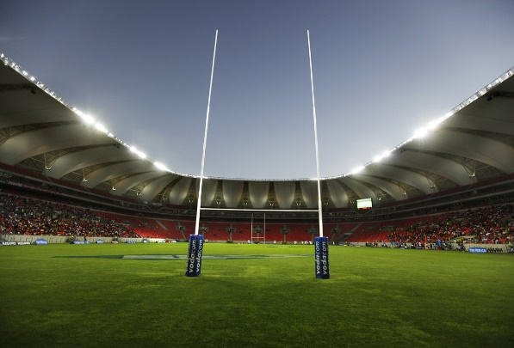
1 Question . . . . . .
Kate Kassar (Director, Beyond Events)
Listen to the client's aspirations and needs. Success then depends on the creation of a dynamic event, which matches and reflects the company culture and the tastes of guests.
Andrew Hodgkins (Premier Service Director, Keith Prowse)
What makes corporate hospitality so successful is being able to offer tickets or packages for events that are sold out or extremely popular.
Alex Hewitt (Managing Director, AOK Events)
Invite your guests to something they genuinely want to attend and ensure you get the right clients attending. Make sure the event is memorable. This way the event lives forever and makes your marketing budget go further.

2 Question . . . . . .
Kate
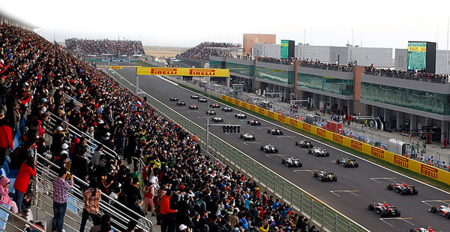
Creating an event with universal appeal to a potentially highly diverse audience. Finding the balance between limitless client aspirations and the boundaries of logistics and cost.
Andrew
The biggest challenge is to make corporate hospitality accessible to everyone - no matter what their budget is.
Alex
Getting the pricing right and making it easy for people to attend. Few of us want to be entertained on a Sunday night at a venue with poor transport links.

3 Question . . . . . .
Kate
Six Nations rugby hospitality in a brewery next to Murrayfield Stadium. It captured the spirit of the rugby audience. Whereas other facilities offered the usual fine dining, this one boasted draught beer, wooden benches, wintery food, rugby celebrities mingling and a party spirit, all on a lower budget.
Andrew
The packages at the Emirates, Arsenal's home ground, are spectacular. and we wish we could have been involved in the Ryder Cup Europe packages.
Alex
A few years ago, my sister invited me to a private sponsor's concert in a tiny London venue in the middle of the Wimbledon fortnight, which featured John McEnroe and Pat Cash on guitar, Nick Mason on drums and Chrissie Hynde on vocals. Fantastic food and an unlimited bar made it the perfect event.

4 Question . . . . . .
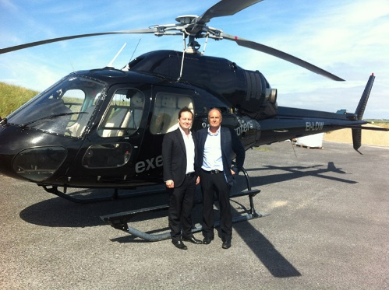
Kate
A one-off interactive experience that money can't buy. An event that gives its audience a real feel of the host brand, combining the adrenaline of sport with the feel-good factor of entertainment and the glamour of the Monaco F I Grand Prix.
Andrew
If we had an unlimited budget, we'd love to offer sporting packages with a twist. For example, offering high-profile former
so sportsmen and women to give clients a coaching session in their chosen sport before the event.
Alex
Morning golf at Wentworth with Tiger Woods and Sean Connery, followed by a helicopter ride to Le Manoir, where Raymond Blanc would oversee a spectacular lunch.

