BE75: Managing People: Discussion and Vocabulary: “A boat can’t have 2 captains”
A: What qualities and skills should a good manager have? Choose the six most important from the list.
To be a good manager you need to:
1 be an expert. 7 make suggestions.
2 like people. 8 judge people's abilities.
3 focus on tasks, not people. 9 plan ahead.
4 enjoy working with others. 10 be good with numbers.
5 give orders. 11 make good presentations.
6 listen to others. 12 be older than your staff.

B: If you are managing people from different cultures, what other personal qualities and skills do you need?
EXAMPLES: personal qualities: flexibility
skills: good at language

C: Talk about the good or bad qualities of managers/bosses you have had.

A: 'Verb + preposition' combinations are often useful for describing skills and personal qualities. Match the verbs (1-7) to the prepositions and phrases (a-g).
A good manager should:
1 respond a) in their employees' abilities.
2 listen b) to a deputy as often as possible.
3 deal c) to employees' concerns promptly.
4 believe d) with colleagues clearly.
5 delegate e) with problems quickly.
6 communicate f) in regular training courses for employees.
7 invest g) to all suggestions from staff.

B: Which do you think are the three most important qualities in Exercise A?

C: Some verbs combine with more than one preposition.
He reports to the Marketing Director. (to someone) The Manager reported on last month's sales figures. (on something)
Say whether these combine with someone, something or both.
1 a) report to someone 4 a) agree with
b) report on b) agree on
2 a) apologise for 5 a) argue about
b) apologise to b) argue with
3 a) talk to
b) talk about

D: Complete these sentences with suitable prepositions from Exercise C.
1 The Finance Director argued . . . . . . . . . . . . our Managing Director over profit sharing.
2 I agreed . . . . . . . . . . . . her that we need to change our marketing strategy.
3 I talk . . . . . . . . . . . . my boss every Monday at our regular meeting.
4 We argued . . . . . . . . . . . . next year's budget for over an hour.
5 He apologised . . . . . . . . . . . . losing his temper.
6 We talked . . . . . . . . . . . . our financial problems for a long time.
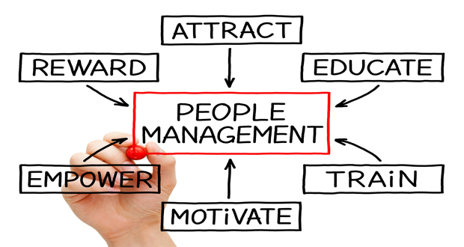
7 I apologised . . . . . . . . . . . . Paula for giving her the wrong figures.
8 Can we agree . . . . . . . . . . . . the date of our next meeting?

E: Write three questions using some of the 'verb + preposition' combinations from Exercises A and C. Then work in pairs and ask each other the questions.
EXAMPLE: Who do you communicate with every day?

F: What is your ideal manager like? Are they male or female?

