BE49: Great Ideas: Listening and Reading
WHO NEEDS TRANSLATORS?
Google is developing software for the first phone capable of translating foreign languages almost instantly. By building on existing technologies in voice recognition and automatic translation. Google hopes to have a basic system ready within a couple of years. If it works, it could eventually transform communication among speakers of the world's 6,000-plus languages.
The company has already created an automatic system for translating text on computers, which is being honed by scanning millions of multilingual websites and documents. So far, it covers 52 languages. Google also has a voice-recognition system that enables phone users to conduct web searches by speaking commands into their phones rather than typing them in.
Now it is working on combining the two technologies to produce software capable of understanding a caller's voice and translating it into a synthetic equivalent in a foreign language. Like a professional human interpreter, the phone would analyse "packages" of speech, listening to the speaker until it understands the full meaning of words and phrases, before attempting translation.

SAFER CYCLING
Swedish designers have created a cycling "collar" that is worn around the neck with an airbag hidden inside. When sensors in the device determine a crash has happened, an airbag instantly inflates around the cyclist's head to form a helmet.
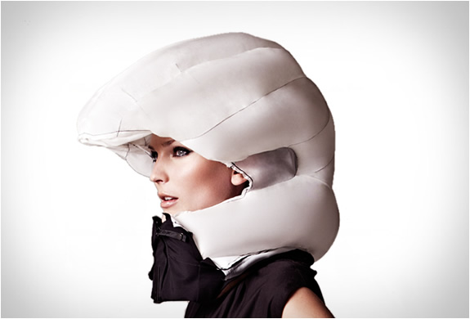
The invention was presented today in Stockholm. It will go on sale in Sweden early next year for about £50. The designers have spent six years developing it. Terese Alstin, one of the inventors, said, "The protection should include keeping the sense of freedom and not ruining your hairstyle."
The device has been improved by recreating hundreds of accidents using crash-test dummies and real riders. "We have developed a unique, patented, mathematical method to distinguish these movement patterns," say the inventors. A small helium gas cylinder inflates the airbag in 0.1 seconds and is designed to let cyclists see at all times.
The airbag stays inflated for several seconds. It is powered by a rechargeable battery. Co-inventor Anna Haupt said. "The shell of the collar is removable and available in many different styles and fabrics, and will be launched in new fashion collections."

Going for gold
Apart from being gold-plated – and the fact that they are bulletproof – they seem much like any other vending machine. But instead of chocolate bars, a network of "gold-to-go" machines dispenses 24- carat bullion in a smart presentation box.
Originally designed as a marketing device for an online gold-trading business, the machines have become such a success that their inventor plans to build a global network, installing them everywhere from fitness centres to cruise ships.
Thomas Geissler, the German businessman behind the machines, said their unexpected success was the result of a recent interest in gold. " Our customers are those who are catching on to the idea that gold is a safe investment at a time of financial instability," he said.
Since the first machine was installed in May, in the lobby of Abu Dhabi's Emirates Palace hotel, 20 gold-to-go machines have appeared across Europe. Germany already has eight. Next month, the first machines will open in the United States - in Las Vegas and Florida.
The company claims its gold is cheaper than that available from the banks, largely because its overheads are lower, and that unlike at a bank, the machine gold is available immediately.

