BE45: Selling: On TV: Listening and Reading
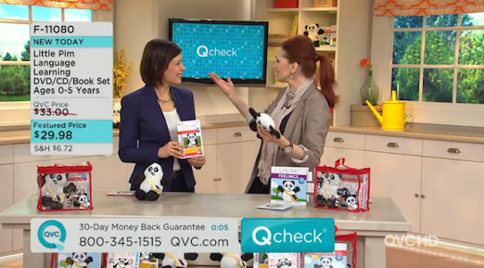
A: Listening: 1.28 Sue Leeson is Director of Marketing at QVC, the global shopping channel. Listen to the first part of the interview and answer these questions.
1 What are the six product groups that she mentions?
2 QVC sells to consumers in which countries?
3 Which two media are used to sell QVC's products?

B: Listening: 1.29 In the second part, Sue talks about the secret of a really good presentation and developing a sales pitch. Listen and complete this paragraph.

Firstly, having a product that you can easily _________________ and a product that has a good _________________ behind it. Secondly, that the person who's actually giving the sales presentation can engage with their _________________in a credible fashion, can tell the story very clearly and can demonstrate the features and _________________ of each product in a very _________________ and easy-to-understand way.

C: Listening: 1.29 Listen again and complete these notes.
You need to know:
• the product __________________________________
• what the product can or can't __________________________________
• when the product is or isn't __________________________________

D: Listening: 1.30 Listen to the third part and answer these questions.
1 Why are beauty products easy to sell on TV?
2 Which type of product is difficult to sell, and why?

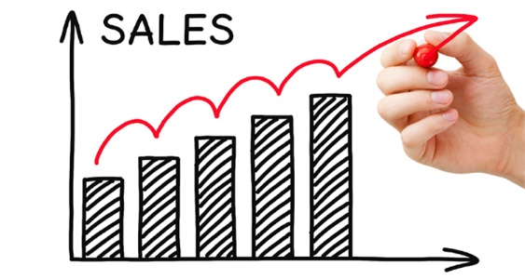
E: Listening: 1.31 Listen to the final part. If customers want to buy a skin product, what four things can they see on the QVC website?

A: Reading: Look at these qualities needed to succeed in sales. Which do you think are the top four?
• personality • honesty
• appearance • organisational skills
• ability to close a deal • ability to deal with people
• confidence • knowing your product

B: Which of the qualities in Exercise A is the most important?

C: Read the article on the opposite page and match each of these headings (a-h) to one of the paragraphs (1-8).
a) Motivation e) Main finding of the survey
b) Professionalism f) Why women make the best salespeople
c) TV g) What the survey asked
d) Personal qualities h) The woman who would make the best salesperson

D: What do these numbers refer to in their article.
a) two-thirds b) half c) 53 d) 66
e) 53 f) 47 g) third h) 41
i) 3 j) 10 I) 55 l) 47
m) 87 n) 86 o) 25-35
